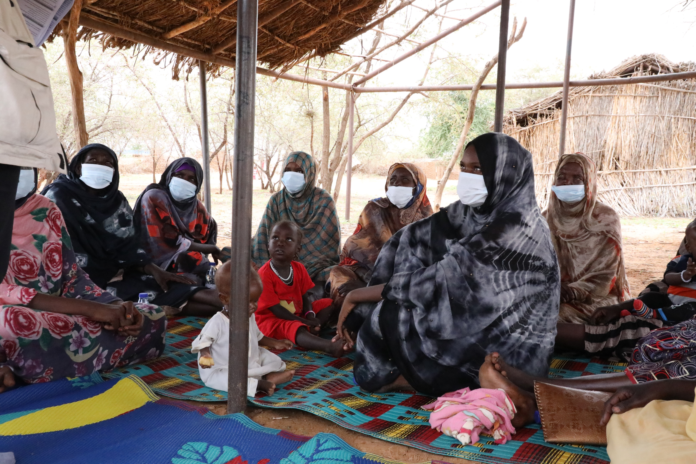
LEGAL IDENTITY & CIVIL DOCUMENTATION
IMPORTANCE OF LEGAL IDENTITY
The Norwegian Refugee Council (NRC) is an independent humanitarian organization helping people forced to flee. We work in crises across 31 countries, providing life-saving and long-term assistance to millions of people every year.
NRC works to protect the rights of displaced and vulnerable persons during crisis. In Sudan, NRC is implementing programmes under the Water sanitation and hygiene, Food security and Livelihoods, Education, Shelter and settlement, Camp coordination & camp management, Information counselling & Legal Assistance areas of competence.
Information, Counselling & Legal Assistance (ICLA) is a legal aid programme seeking to assist displaced persons to claim and fulfil their rights through application of information, counselling and legal assistance services.
In Sudan NRC ICLA conducts activities on Housing Land and Property (HLP) issues, Civil and Identity Documentation and Employment laws and procedures.
THE NORWEGIAN REFUGEE COUNCIL
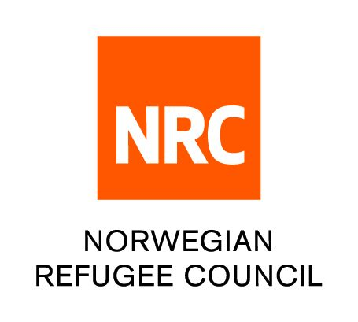
All information provided in this document is intended as a general guide only and is not a substitute for seeking advice from a qualified lawyer and/or government authorities. The information in this leaflet is subject to change and individuals should ensure that they obtain up to date information

INFORMATION SHEET ON

Legal identity
- Legal identity refers to the right to be recognized as individual before the law and entitles an individual to certain rights and protection under the law.
- According to International law, every person has the right to be recognized before the law.

Why we should we register vital incidents and obtain legal identity documents?

Importance of legal identity
- The lack of legal identity can reduce or eliminate the ability of individuals to access basic services, including access to health, food, education, shelter, formal employment, business licences, and welfare schemes or even enter simple agreements both during and after displacement.
- Identity documentation plays a complementary role with civil documentation. Displaced persons may be unable to register their births or marriages because they lack adequate identity documentation. Similarly, individuals may be unable to apply for identity or travel documents without proof of date or place of birth certified by an official birth certificate.
- To access a number of public services including;
- Formal employment - recruitment into public, private or mixed sectors
- To engage with the formal justice system, i.e courts
- Open a bank account;

For refugees;
- Lack of identity documents may increase the risk of detention, imprisonment and harassment by law enforcement authorities.
- Identity documents are additionally required to obtain work permits.
- Identity documents are required to obtain movement permits to travel without facing the threat of detention, imprisonment, or possible expulsion.
- Lack of identity documents can put an individual at higher risk of statelessness.

Importance of vital incident registration and issuance of civil documentation
- Obtaining civil and identification documents are essential in establishing and realising many human rights embodied in international declarations and conventions. Lack of access to these rights and services perpetuates exclusion and vulnerabilities.
- Lack of documentation may make it difficult to enforce specific rights such as marital rights to claim child custody and alimony, inheritance, succession, communal property, family reunification etc.

For refugees
- Lack of birth registration may increase the risk of statelessness. Individuals without birth registration documents may have difficulty in proving their legal identity, and thus their bond to their state of origin.
- Family re-unification - When families are separated during emergencies the absence of documents can make reunification difficult

THE DIGITAL COMMUNITY HUB
- Call NRC for free on 015 655 9807
- Information available in English, Arabic, Tigrinya and Amharic (from 8:00 AM to 4:00 PM every day).
- If you are a Refugee or Internally Displaced Person in Khartoum, get information on obtaining legal documents and on our Cash for Food Programme.
- The call will not cost you anything.
- You can also leave us a message with your complaint or feedback on our services and we will get back to you (Sunday - Thursday, between 8:00 AM and 4:00 PM)

www.nrc.no

